It Doesn’t Matter if You Win or Lose…
Its How You Make the Game

This week we have studied the French Revolution and the philosophies behind revolution. Now you are going to have the opportunity to create a game based on the material covered in this unit.

In order to successfully create this game, you will be divided up into groups of three. Each group will have access to materials needed to create a game board: including cardboard, paper, markers, colored pencils, glue and scissors. The rest is up to you!

Your first task is to choose a topic for your game. Your options are:
- Philosophy—meaning you create a knowledge based game of the major philosophers we studied (i.e. Rousseau, Locke, etc.)
- French Revolution (Pre-Napoleon)
- Napoleonic Era

After you choose your topic, you will want to consider what type of game you will create. Will it be a trivia game (Like a Trivial Pursuit or Jeopardy)? Will it be a game of world domination (Like Risk)? Will it be a question and answer board game (Like Clue)? Consider what options will work best for your group. Whatever you choose—make SURE that you cover the relevant content of your topic! Remember—you have three key focuses here: to demonstrate what you have learned about your topic, to demonstrate how your game will be relevant, and to show off your creativity!

Grading will be based on the information assigned above and according to the rubric on the back of this handout.

Good luck and have fun!

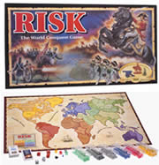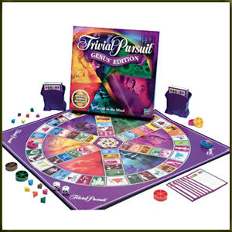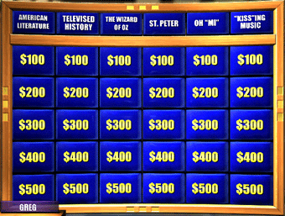

Making A Game : French Revolution Game

Teacher Name: Mr. Pond
Student Name: ________________________________________

CATEGORY | 94-100 | 85-93 | 76-84 | Under 75
Accuracy of Content | All information made for the game is correct. | Most of the information made for the game is correct. | Some of the information made for the game is correct. | Little information made for the game is accurate.
Attractiveness | Contrasting colors and at least 3 original graphics were used to give the cards and gameboard visual appeal. | Contrasting colors and at least 1 original graphic were used to give the cards and gameboard visual appeal. | Contrasting colors and "borrowed" graphics were used to give the cards and gameboard visual appeal. | Little or no color or fewer than 3 graphics were included.
Cooperative work | The group worked well together with all members contributing significant amounts of quality work. | The group generally worked well together with all members contributing some quality work. | The group worked fairly well together with all members contributing some work. | The group often did not work well together and the game appeared to be the work of only 1-2 students in the group.
Creativity | The group put a lot of thought into making the game interesting and fun to play as shown by creative questions, game pieces and/or game board. | The group put some thought into making the game interesting and fun to play by using textures, fancy writing, and/or interesting characters. | The group tried to make the game interesting and fun, but some of the things made it harder to understand/enjoy the game. | Little thought was put into making the game interesting or fun.

